**HTML | <th> colspan Attribute**

Last Updated : 01 Aug, 2022

 The **<th> colspan Attribute** in HTML is used to specify a number of columns a header cell should span.

**Syntax:**

<th colspan="number">

**Attribute Values:** It contains single value **number** which contains the numeric value to sets the number of column a header cell should span.

**Example:** This example illustrates the use of colspan attribute in <th> tag.

* html

|  |
| --- |
| <!DOCTYPE html>  <html>      <head>          <title>HTML colspan Attribute</title>          <style>              table, th, td {                  border: 1px solid black;                  border-collapse: collapse;                  padding: 6px;              }          </style>      </head>        <body>            <h1 style = "color: green;">GeeksforGeeks</h1>          <h2>HTML &lt;th&gt;colspan Attribute</h2>            <table>              <tr>                  <th colspan="2">Expense</th>              </tr>                <tr>                  <td>Arun</td>                  <td>$10</td>              </tr>                <tr>                  <td>Priya</td>                  <td>$8</td>              </tr>          </table>      </body>  </html> |

**Output:**

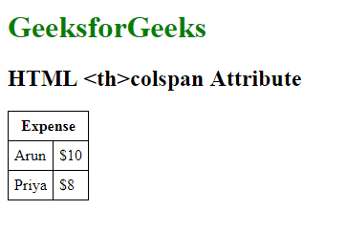

**Supported Browsers:** The browser supported by **HTML <th>colspan attribute** are listed below:

* Google Chrome 1 and above
* Edge 12 and above
* Internet Explorer
* Firefox 1 and above
* Opera
* Safari

Dive deep into the world of JavaScript with our [JavaScript Full Course Online](https://www.geeksforgeeks.org/courses/javascript?utm_campaign=three_90_345_abt&utm_medium=gfgcontent_abt&utm_source=geeksforgeeks), offering everything from the basics to advanced techniques. Learn how to build interactive websites, optimize your code, and earn a certification to showcase your skills.